Colegio Chile
Departamento de Inglés

UNIT 1 “FOOD AND HEALTH”
Objetivo: Identificar vocabulario relacionado con alimentos y asociar imágenes con pronunciación de palabras y demostrar comprensión lectora de texto relacionado con vocabulario de la guía.
Instrucciones:
- Lee atentamente las instrucciones de cada ejercicio, utiliza diccionario o traductor si necesitas ayuda.
- Tienes plazo para enviar la guía hecha hasta el Viernes 20 de Marzo.
- Debes enviar la guía resuelta y en la fecha indicada al mail missmayraoyanedel@gmail.com (6° A y B) y missandreafloresc@gmail.com (6° C y D) para revisar tu trabajo. Si tienes dudas o quieres practicar más puedes escribirnos.

Name: | Grade: | Date:

- Name these meals correctly.

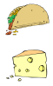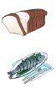

- Find the words from exercise I in this word search.
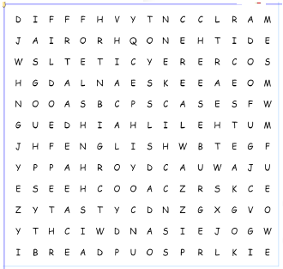
- Fruits and vegetables vocabulary.

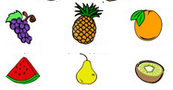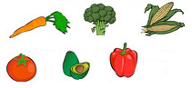
12
11
10
9
7
8
6
5
4
3
2
1

- _________________________
- _________________________
- _________________________
- _________________________
- _________________________
- _________________________
- _________________________
- _________________________
- _________________________
- _________________________
- _________________________
- _________________________

- Read the text and answer the questions.

Tom goes to eat breakfast
Tom wants to eat breakfast. He goes to the restaurant. He is hungry. He orders a slice of pizza, a cup of tea and a carton of milk. The waiter asks tom if he wants something else. Tom says, he wants a piece of cheese and a bowl of soup. Tom eats all his food and pays the bill. He is full now. He goes to work.

- Where does Tom goes? ___________________________________________________
- What does he order? _____________________________________________________
- What does the waiter ask him?______________________________________________
- How does Tom feel after eating? ____________________________________________
- Where does Tom go after eating? ___________________________________________

People often go to the supermarket.
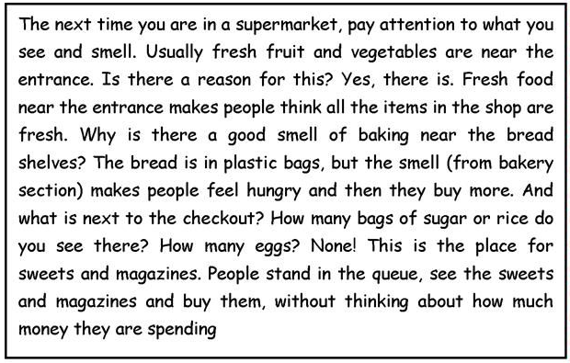

- Where are usually vegetables and fresh fruits in a supermarket?
_____________________________________________________________
- Why?
_____________________________________________________________
- Why is the smell from the bakery section?
_____________________________________________________________
- What are there near the checkout?

Now I suggest you click the links and visit the web page for more practice
https://www.languageguide.org/english/vocabulary/vegetables/
https://www.languageguide.org/english/vocabulary/food2/

