

Colegio Chile

Departamento de Inglés

**UNIT 1 “HOME TIME”**

**Objetivo:** Identificar vocabulario relacionado con Rutinas diarias, asociar letras del alfabeto con su pronunciación y deletrear palabras de la unidad 1

Instrucciones:

* Lee atentamente las instrucciones de cada ejercicio, utiliza diccionario o traductor si necesitas ayuda.
* Tienes plazo para enviar la guía hecha hasta el Viernes 20 de Marzo.
* Debes enviar la guía resuelta y en la fecha indicada al mail [missandreafloresc@gmail.com](mailto:missandreafloresc@gmail.com) para revisar tu trabajo. Si tienes dudas o quieres practicar más puedes escribirme.

|  |  |  |
| --- | --- | --- |
| Name: | Grade: | Date: |

1. Watch the video and write the name of the daily routines under the image that correspond.

<https://www.youtube.com/watch?v=qD1pnquN_DM>

    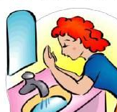

    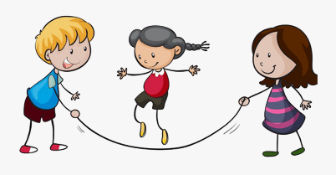

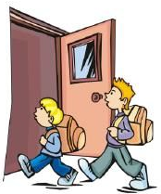  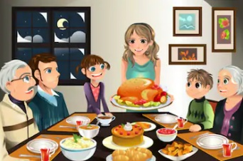  

1. Find and circle the words in the word search puzzle. If you don’t know a word, use your dictionary and write next to it their meaning.



1. Get up
2. Take a shower
3. Brush teeth
4. Shave
5. Get dressed
6. Put on makeup
7. Brush hair
8. Comb hair
9. Make the bed
10. Have a bath
11. Make breakfast
12. Have breakfast
13. Go to work
14. Go to school
15. Go to bed
16. Sleep
17. Number the images with the words on exercise 2.

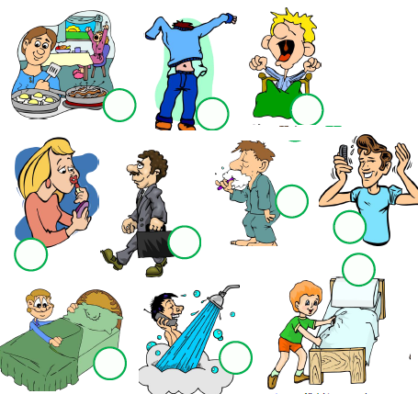



1. Watch and Listen to the video and write under the letter the pronunciation. <https://www.youtube.com/watch?v=Pw0Iak_OUE0>









** Do you observe something special in the video? What was it?

________________________________________________________________________________

1. Read the following words and write their correct spelling.
2. Breakfast: _________________________________________________________________
3. School :___________________________________________________________________
4. Get up: ___________________________________________________________________
5. Lunch: _____________________________________________________________________
6. Homework:_________________________________________________________________
7. Brush: _____________________________________________________________________
8. Play:_____ __________________________________________________________________